PUBLIC TRANSPORTATION EFFICIENCY ANAYSIS

**INTRODUCTION:**

Metropolitan areas have experienced in the last decades an increasing expansion bringing, as a consequence, several socio-economic problems such as an unequal spatial urban development, a high pressure on disposable infrastructure, land and housing shortages, and, with emphasis, lack of urban services. These problems, in addition to low income and unemployment, expel poorer people to urban peripheries where housing costs are lower. But these peripheries are diploid of public services and increase the cost of providing urban infrastructure. Public transport, in particular, planned to operate in more density populated areas, offer a lower frequency and quality service, due in part to larger distances and a precarious road system. Unorganized urban expansion leads to an unorganized and irrational transport system in which superimposition of routes is one of its characteristics. In addition, municipal system if not centrally coordinated results in superimposition and low coordination of routes and irrationality of the whole system.

Urban expansion, a conurbation phenomenon in which city limits loose expression bring planning difficulties. Notwithstanding the difficulties, people require in each area an adequate public transport that allows easy moves to work, shopping, educational, health, and cultural centres. Thus, a metropolitan public transport system needs to assure mobility and accessibility through a fast, secure, regular, and trustable transport at a reasonable cost. Unfortunately it is not easy to assure all these characteristics due to complex institutional arrangements between state and several municipalities. Thus, a first step consists of working an agreement among all political institutions involved. In particular, questions such as power division among them, administrative coordination, financing, and selection and operation of all concession to operate the several services involved (bus, metro, vans, and so).

**OBJECTIVE:**

The main objective of this paper consists of directive propositions to a new institutional arrangement to the public transport Area based on efficiency analysis of several public transport systems. A data analysis – DA is adopted to select efficiency systems and their characteristics are analysed to highlight key propositions that may help the improvement of public transport system.

**QUALITY AND EFFICIENCY IN PUBLIC TRANSPORT:**

Quality and efficiency of public transport systems may be analysed based on several factors relating to the quality of the service that is offered – service performance - and to the performance of the agencies and companies in charge of it. As an example, Santos (2000) points several characteristics required for a good performance:

* System accessibility, determined by the distance between users origin and the initial station and between the last station and the final destination. The shorter this distance higher is route availability and, as a consequence, geographical coverage increases, making it easy and better to people to move from one place to the other.
* Travel time, determined by velocity and geometry of routes. Velocity is a function of distances, of traffic conditions and road quality. The geometry of routes is a function of the development of a complex connection of more direct and subsidiary routes.
* Trustworthiness, determined by uncertainty of time schedules. It can be measured by the number of trips on time in relation to the other with delay and how much are the delay. Punctuality bring users trust and fidelity.
* Frequency, determined by the time interval between each trip. Users must know the timetables, and its changes along the day, during weekends and other special occasions.
* Maximum load, determined by the number of passengers in rush hours in relation to vehicle capacity.
* Vehicle characteristics, including age, conservation and technology all bringing users comfort. Conservation requires general maintenance, and noise and temperature control. By technology one also understands door size, steps and adoptions required by special passengers.
* Adequate information and support facilities, such as covered stations, schedule and timetable information, clear indications of stations and vehicles.
* Mobility in accordance with necessities, that is, routes must be planned to cover the whole area and allow flexibility in choosing an appropriate route. In addition, adaptations are required to attend passengers with motion restrictions.

Besides quality requirements, efficiency is related to performance indicators, such as low operational cost to users, minimum number of vehicles and personnel but without a decrease in the quality of service provided. And efficacy is related to the number of users of public transport in relation to population, kilometres of routes provided in relation to area, and the satisfaction level, all represent in a high quality service for the lowest fare as possible.

**MEASURING EFFICIENCY IN PUBLIC TRANSPORT – A DATA ANALYSIS:**

The efficiency of transport systems is determined by a Data Analysis–DA. Urban transport systems are considered decision making units – DMUs that relatively measured in relation to those that determine the efficiency frontier. There are two major approaches – a parametric and a non-parametric one. Parametric frontiers are characterized by a production function of constant parameters. This method was originally developed by Chu (1968). A functional form is defined and usually it is estimated by econometric models. The specification of a functional form is the main limitation of the parametric approach, as efficiency measures vary according to the adopted function. The non-parametric approach does not require the a priori specification of a function. The estimation of the frontier of the production set only requires that the production set satisfy some properties. The DEA method, a non-parametric approach, uses mathematical programming to estimate production frontiers and calculus efficiency scores.

This method is based in the seminal paper by Farrell (1957) as later proposed by Charnes et al (1978). In the DEA method, DMUs are assumed similar and differences results from input use and output obtained. It is assumed that the production set satisfy certain properties, as mentioned, but no assumption is made in relation to the frontier. The production set is limited by a frontier that connects DMUs considered efficient. DMU efficiency determination results from estimation of a system of linear equation. The model proposed by Charnes et al (1978), assuming constant returns to scale, may be represented by N firms or DMUs that use I input to obtain P products. Input and output quantities are represented by xi and yi and i refers to the ith DMU. The objective is to obtain a non-parametric frontier that envelopes the data in a manner that all united are placed on or under this frontier.

For each DMU the ratio between the weighted sum of inputs and the weighted sum of outputs is maximized, where u is a Px1 vector of weights associated to outputs and v a Ix1 vector of weights associated to inputs. The unknown vectors u and v are obtained as a result of the efficiency maximization of each DMU.

**For each DMU the following problem is solved:**

The model presented obtains infinite solutions. If (u*, v*) is a solution, so (αu*, αv*) is also a possible solution. This problem was solved by Charnes (1978) imposing the condition vtxi = 1.

**Thus, the new programming model is:**

This new model is known as a multiplicative model and presents a great number of restrictions. Using the linear programming dual property, the problem may be present in an equivalent form but with a smaller number of restrictions (I+P < N+1).

The linear programming model is solved N times, one for each DMU. The efficiency score θ might satisfy the condition θ ≤ 1. Adopting the constant returns to scale assumption when not all DMUs are operating with optimal scale, may result in efficiency measures influenced by the scale efficiency. In

Max u,v (utyi / vtxi),

Subject to (utyj / vtxj) ≤ 1, j = 1, ..., N,

U ≥ 0 e v ≥ 0

Max u, v utyi,

subject to vtxi = 1,

utyj – vtxj ≤ 0, j = 1, ..., N,

u ≥ 0 e v ≥ 0

Min θ, λ θ,

Subject to Yλ - yi ≥ 0,

θxi - Xλ ≥ 0,

λ ≥ 0.

**Onde:**

θ – Efficiency Score

λ – Nx1 constant vector

X – Input Matrix (IxN );

Y – Output Matrix (PxN).

This case, adopting variable returns to scale allows the measurement of efficiency independent of scale efficiency.

The model for variable returns was developed by Banker et al (1984), by addition of a convex restriction (ztλ = 1):

Min θ, λ θ,

Subject to Yλ - yi ≥ 0,

θxi - Xλ ≥ 0,

ztλ = 1,

λ ≥ 0

Where: z – N x 1 unitary vector.

# One of the advantages of the DA approach for measuring efficiency is that it produces automatically “target units” when inefficient units are found. These “target units” may be “virtual” and do not really need to correspond to a real DMU, that is, the “target unit” may be a linear combination of efficient units in relation to an inefficient DMU. Thus, at the same time that the DEA model identifies that a certain DMU is inefficient it also identifies the DMUs in relation to which this DMU is inefficient. It is determined a set λ weights, indicating a combination of efficient units and representing the output proportion that an inefficient unit could obtain using less inputs, in relation to “target units” (Regis, 2001)

**ANALYSIS:**

The efficiency scores were analysed according to the following criteria: power partition among the components of the administrative agency of the transport system and tariff structure.

**Efficiency and Power Partition:**

Power partition among components of the administrative agency varies much for the analysed systems. It varies in the number and representation of components and also in the percentage of votes that each component possess. According to some rules in (2005), the more power is distributed among components the easiest the decision process and the acceptance of decisions by the components of the agency. On the other hand, the predominance of one agent (more than 50% of the votes) weakens the partnership as it can decide practically alone. If the predominance makes it easy to take decisions (does not depend on other partners) and may lead to higher efficiency it weakens the partnership and as a consequence a division of responsibilities and costs. A partnership among governments and user associations is another important aspect to validate the system.

To comparatively analyse the systems in relation to power partition, a index is proposed:

Y = N.[1 – (K1-K2)/K1]

K1 = (100/N).∑ [Nj+∑ (Ni+1)] e K2 = ∑ Pj[Nj+∑ (Ni+1)]

subject to Pi < Pi+1

Where N is the number of components of the administrative agency and P is the percentage of votes (places) corresponding to each component. Making Ni = 1 and defining NN+1 = 0, the value of the expression [1 – (K1 K2)/K1] varies from 0, when power partition is unequal to the maximum, to 1, when it is equal to the maximum. This expression is similar to the coefficient used to analyse the income inequality (San, 1973). The expression is multiplied by N to express that the higher is the number of participants (components) more efficient the system is expected to be. Taking the value for each system the Y index was calculated.

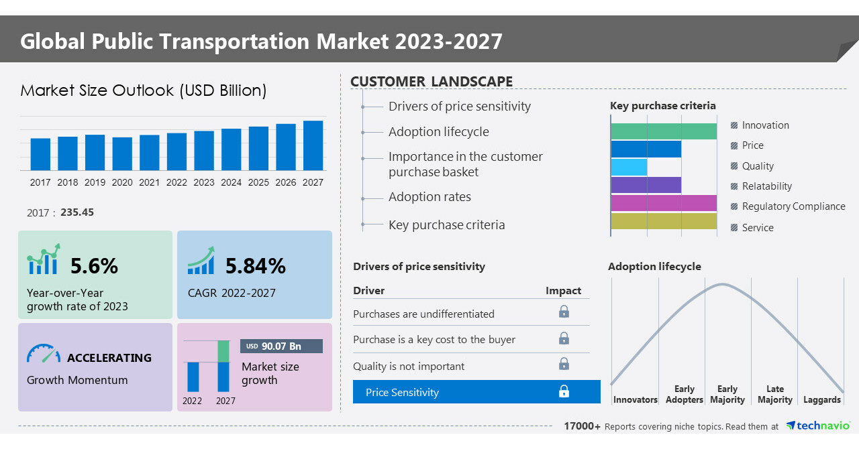

**CONCLUSION:**

The conclusion of this paper consists of directive propositions to a new institutional arrangement for the efficiency of public transportation Area based on efficiency analysis of several public transport systems. A data analysis – DA is adopted to select efficiency systems and their characteristics are analysed to highlight key propositions that may help the improvement of public transport system.